**AWS Task-3**

1. Create a S3 bucket, with no public access and upload files to the bucket & view the logs using CloudWatch for the uploaded files.

* s3 bucket with no public access:

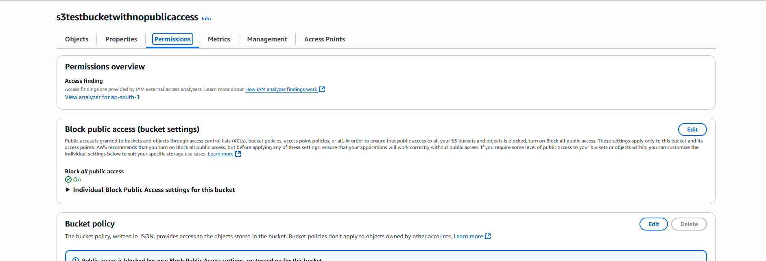

* logs using CloudWatch for the uploaded files:

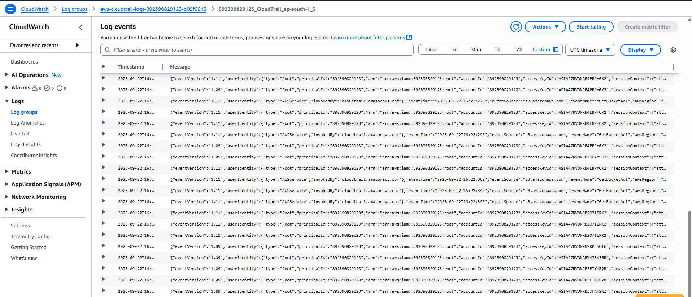

1. Launch two ec2-instances and connect it to a application load balancer, where the output traffic from the server must be an load balancer IP address

EC2 Instance1:

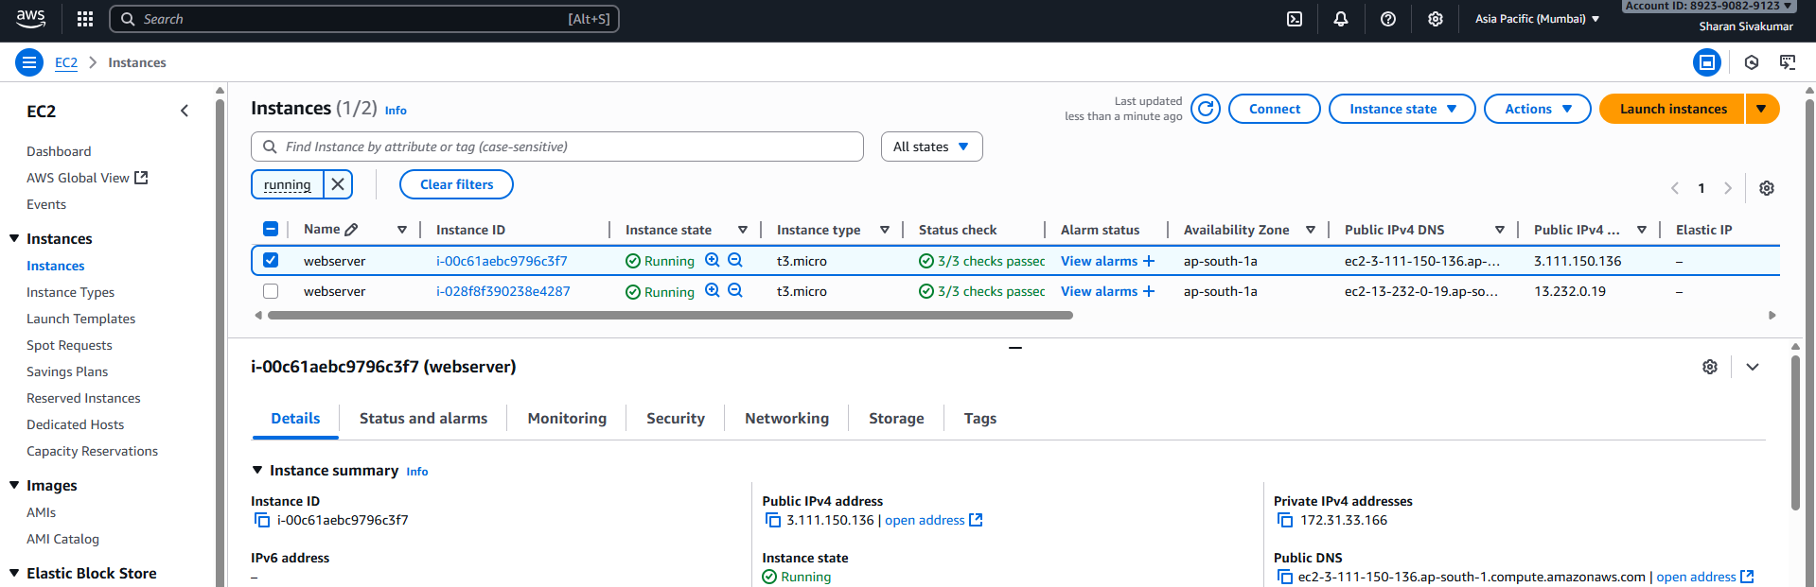

Instance1 IP output:

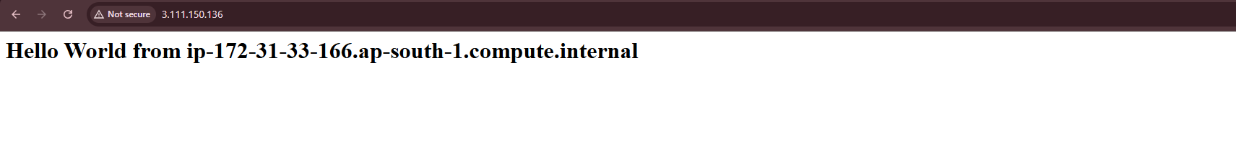

EC2 Instance2:

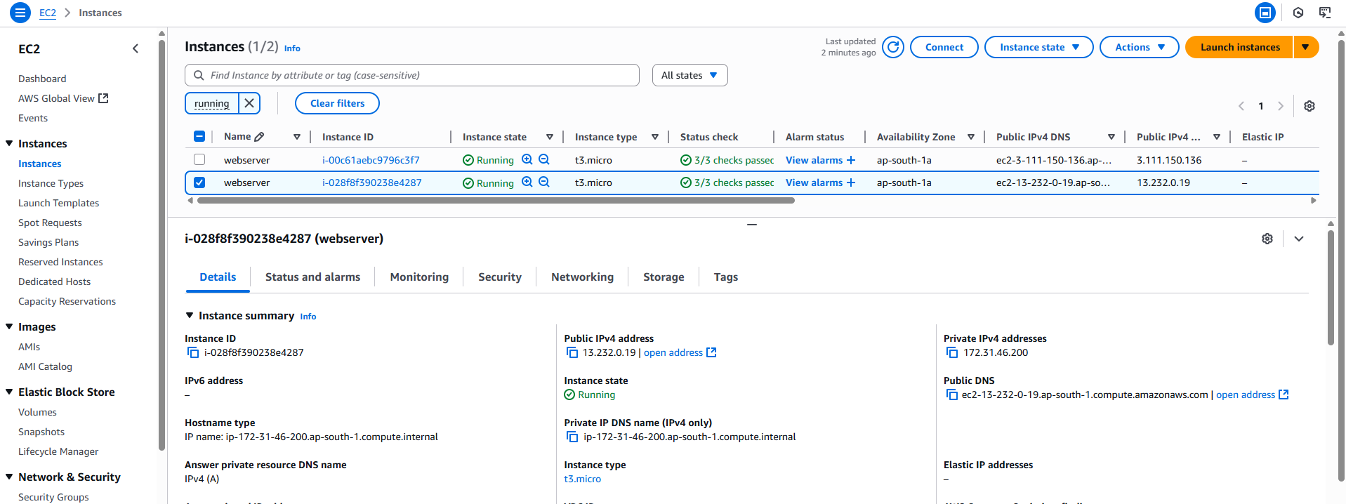

Instance2 IP output:

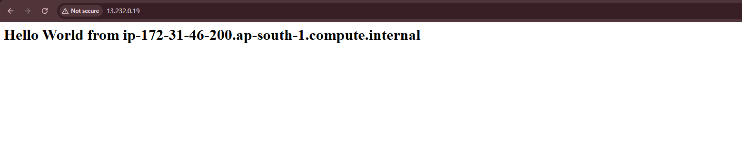

Application Load Balancer:

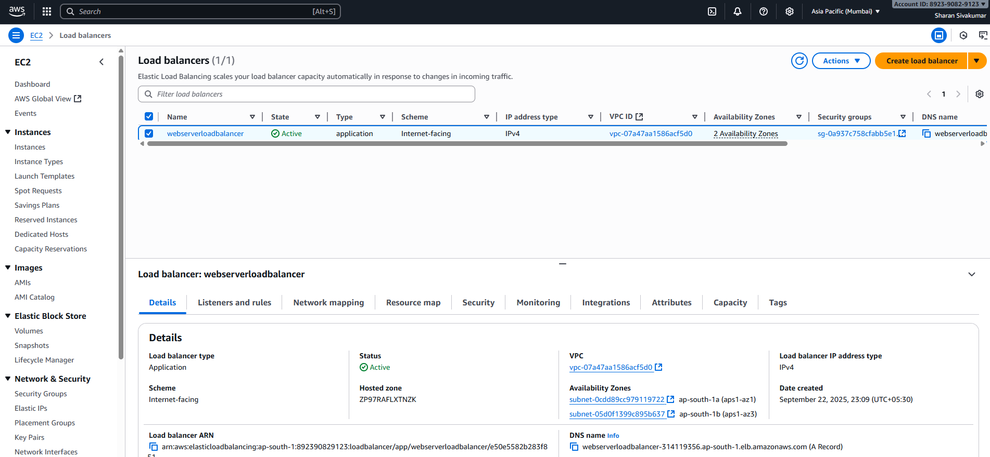

output traffic from the EC2 instances trough Load balancer

